**Centennial College**

**Comp 301: UNIX/LINUX Operating Systems**

**TEST 02**

**Time: 60 minutes [Open Book]**

**Full Marks: 15**

NAME: Mudrak Patel

Student No.: 300878960

**Instructions:** Take a screen shot for each task and place it under the question.

The command used should be clearly and completely visible in the screen shot.

For shell scripts, take a screen shot of the shell script and the screenshot of the result after running the shell script. The shell scripts should have appropriate comments and the shell specified.

1) Create a new file called CD_list with the contents as shown below. Use *uniq* command to select only unique records in the file and store it in a file named “CD_list_1”. Show the screenshot of whatever commands you use to find the unique records and the screenshot of using *cat* to view the contents of CD_list_1.  **(1 mark)**

country,1000,210

soundtracks,1007,32

light rock,1004,151

rock,1001,380

classical,1002,52

alternative,1003,122

light rock,1004,151

celtic,1005,44

jazz,1006,62

soundtracks,1007,32

**My Outputs:**

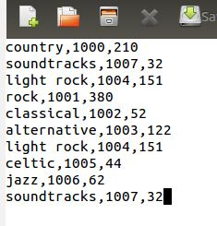

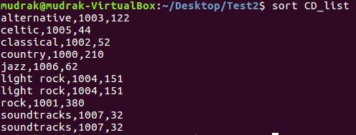

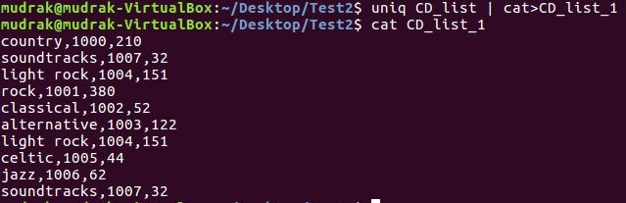

2) Count the number of times, the word ‘soundtracks’ appears in the file CD_list. **(1 mark)**



3) Use the *awk* command to make the contents of the file CD_list appear in the following format (Three sample rows are shown. Do so for all the rows in the CD_list file). Save the file as “CD_list_3”. **(1 mark)**

Genre Albums Sold in US Albums Sold in Canada

country 1000 210

soundtracks 1007 32

light rock 1004 151

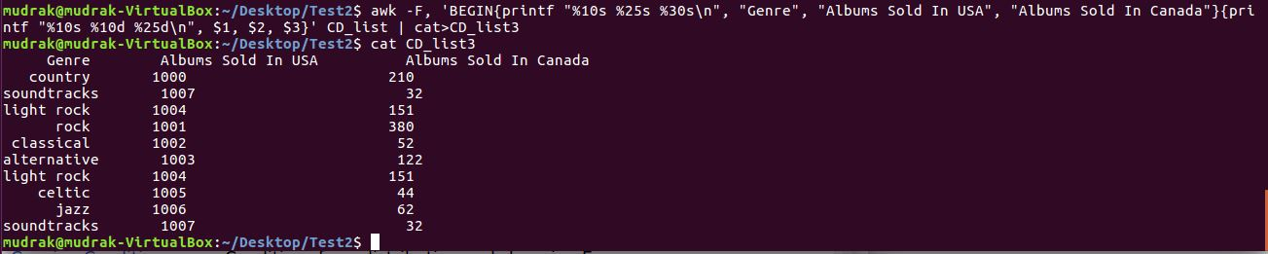

4) Replace all occurrences of the word “light rock” with “easy listening” and the word “alternative” with “experimental” using the *sed* command and save it in a new file called “CD_list_4”. **(1 mark)**



5) Use *cut* command to extract only the first field in the file “CD_list” containing the Genre of music and save it as “CD_list_5”. **(1 mark)**

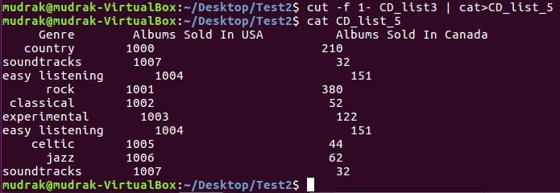

6) Write a shell script to add any two numbers and display the results. The shell script should read the numbers as input from the user. **(2 marks)**

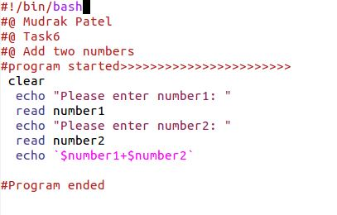

7) Create an alias called ‘*rd’* in your .bashrc file which removes a directory with all its contents. **(2 marks)**

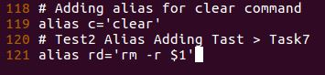

8) Create a .exrc file such that the vi editor shows line numbers by default when you open it. Show the screenshot of the changes made to achieve this.**(1 mark)**

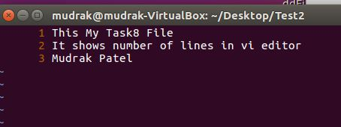

9) Create a shell script that reads a filename from the user. If the file already exists on the Desktop, it displays the message “Sorry file already exists!” else it creates a file on the Desktop with the filename entered by the user and displays the message “File created!” after creating the file.**(2 marks)**

10) Create a shell script to display all the numbers that are divisible by the number 5 from 1 to 50. In the shell script, write a shell function called *checknum* that checks if the number is divisible by 5 and prints it if it is divisible by 5. **(3 marks)**